1.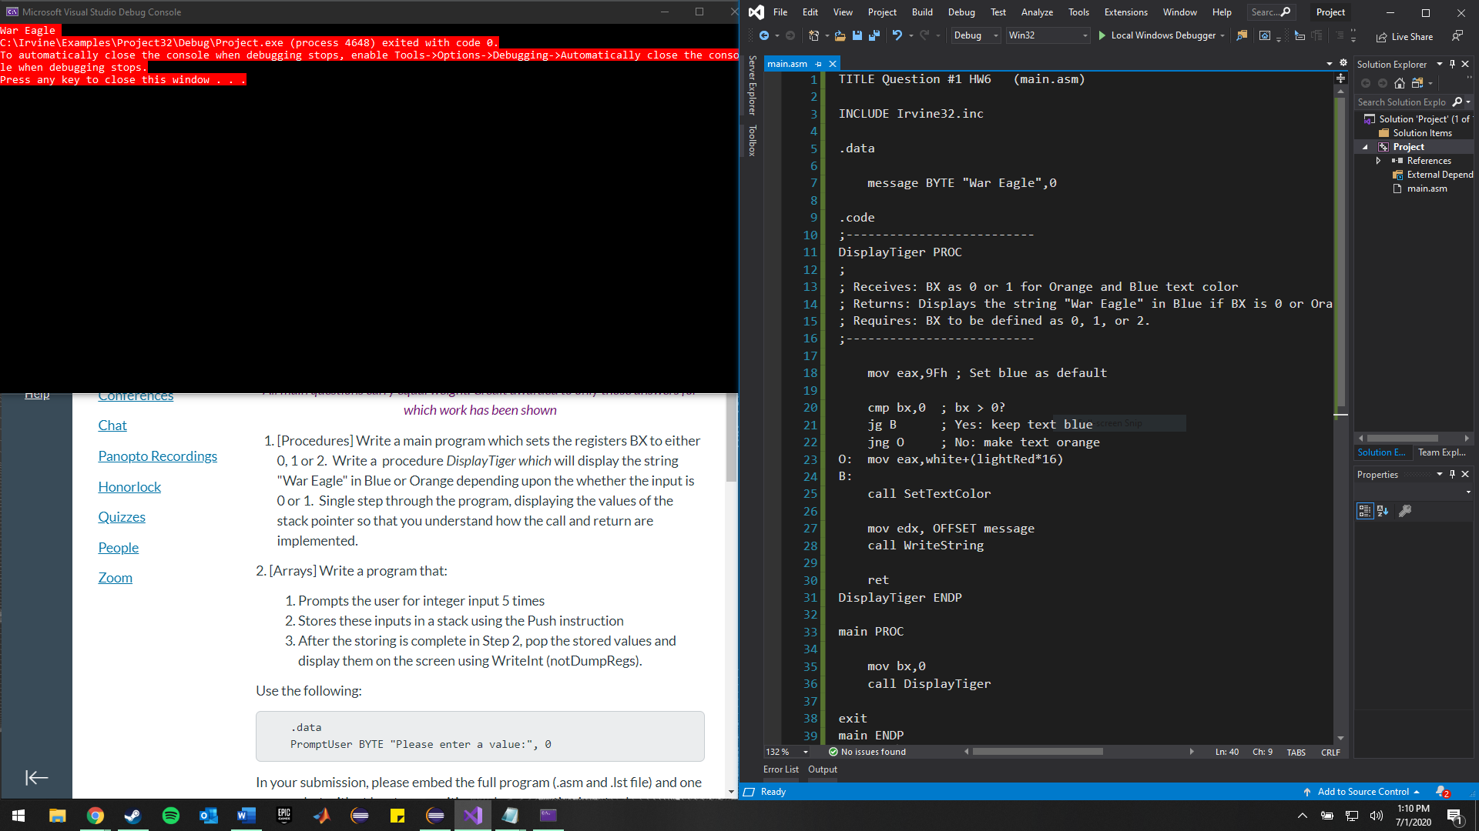

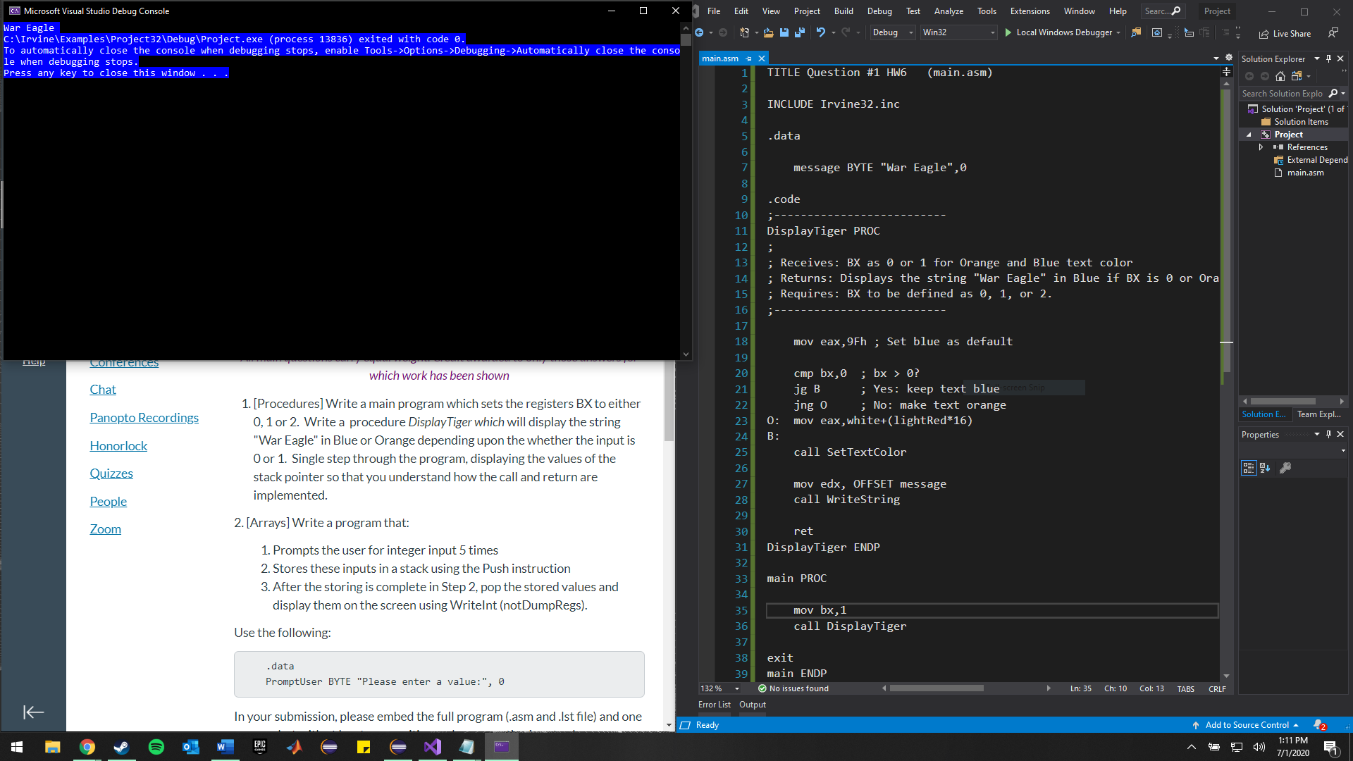

Set the background color (for better visibility) to Blue or Red for BX = 0 or 1. Irvine32.inc does not include an orange color.

2.

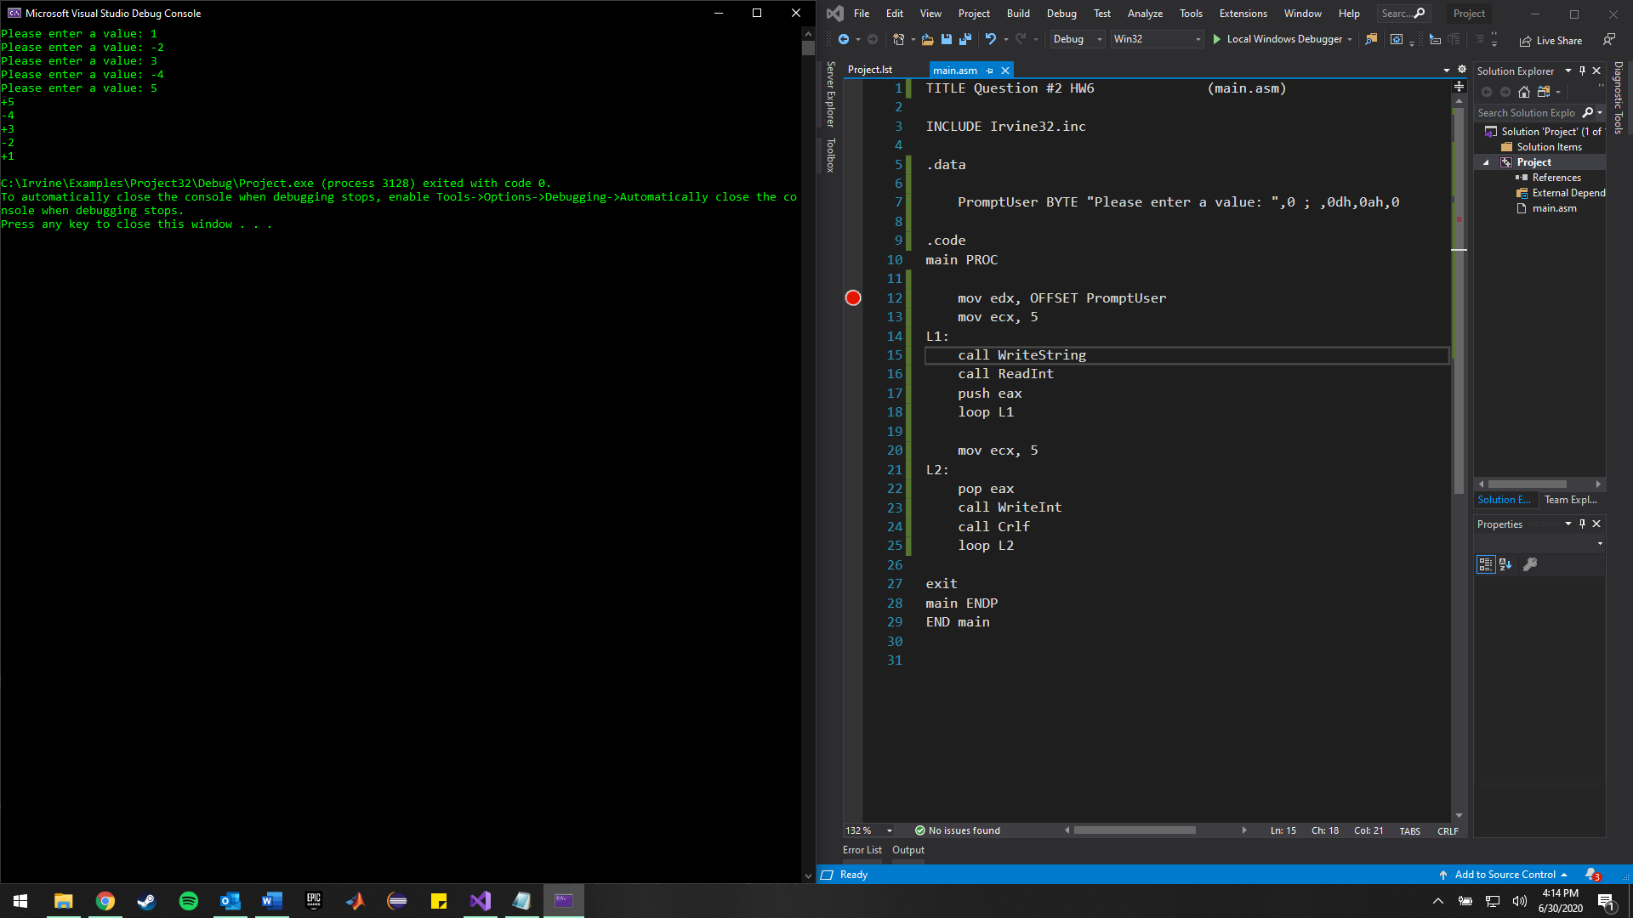

Full code of program shown with working positive and negative inputs.

3.

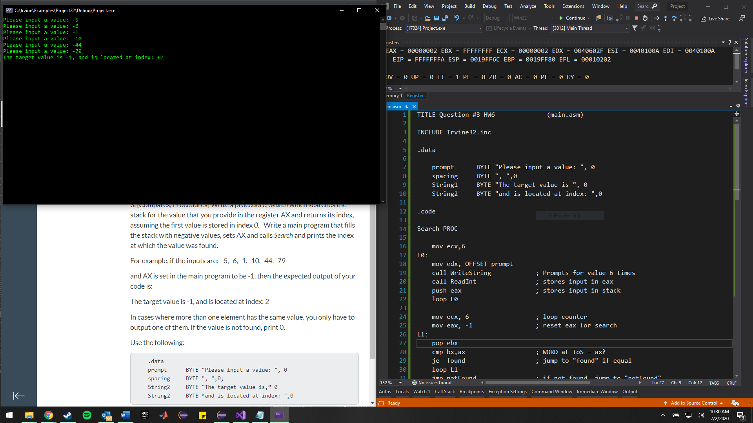

Screenshot shows AX set to -1 in main program, inputs are from example in problem.

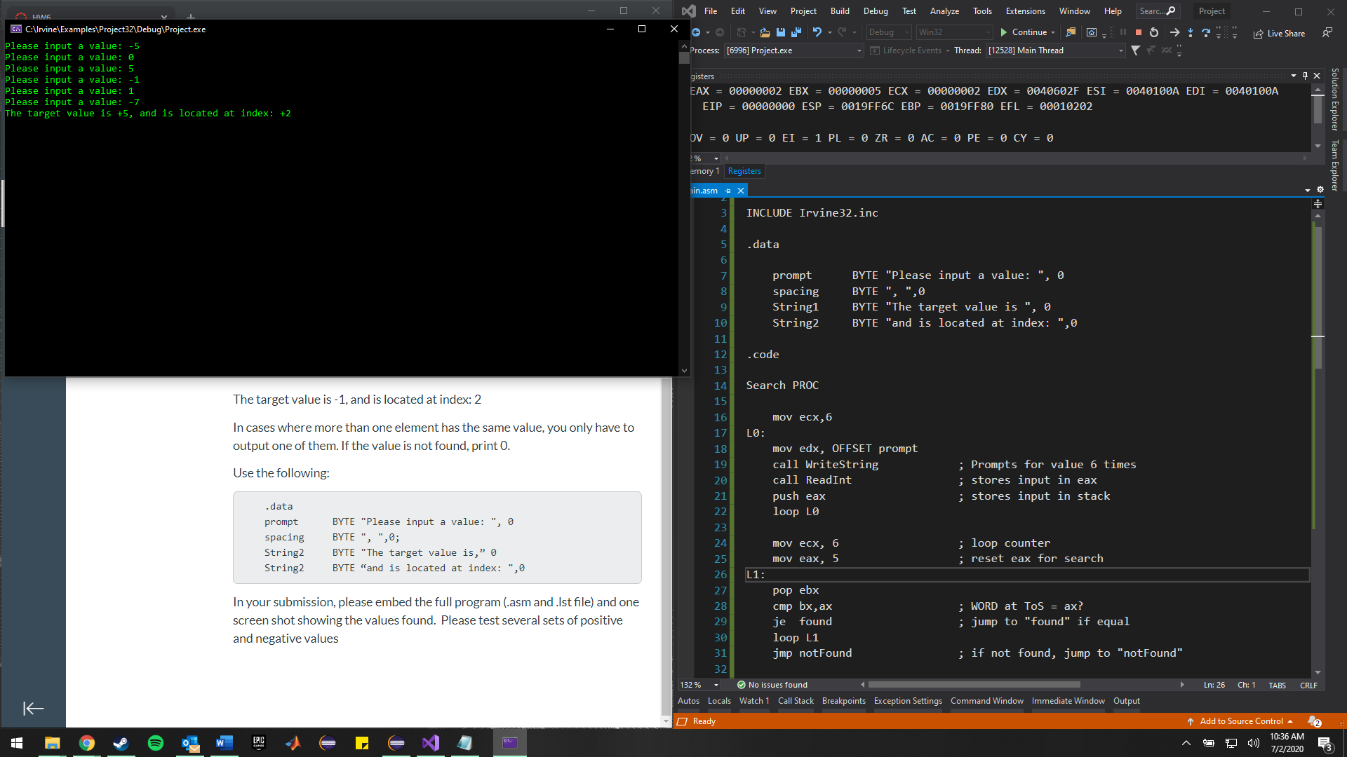

Testing a positive value with + and – inputs. Target is 5.

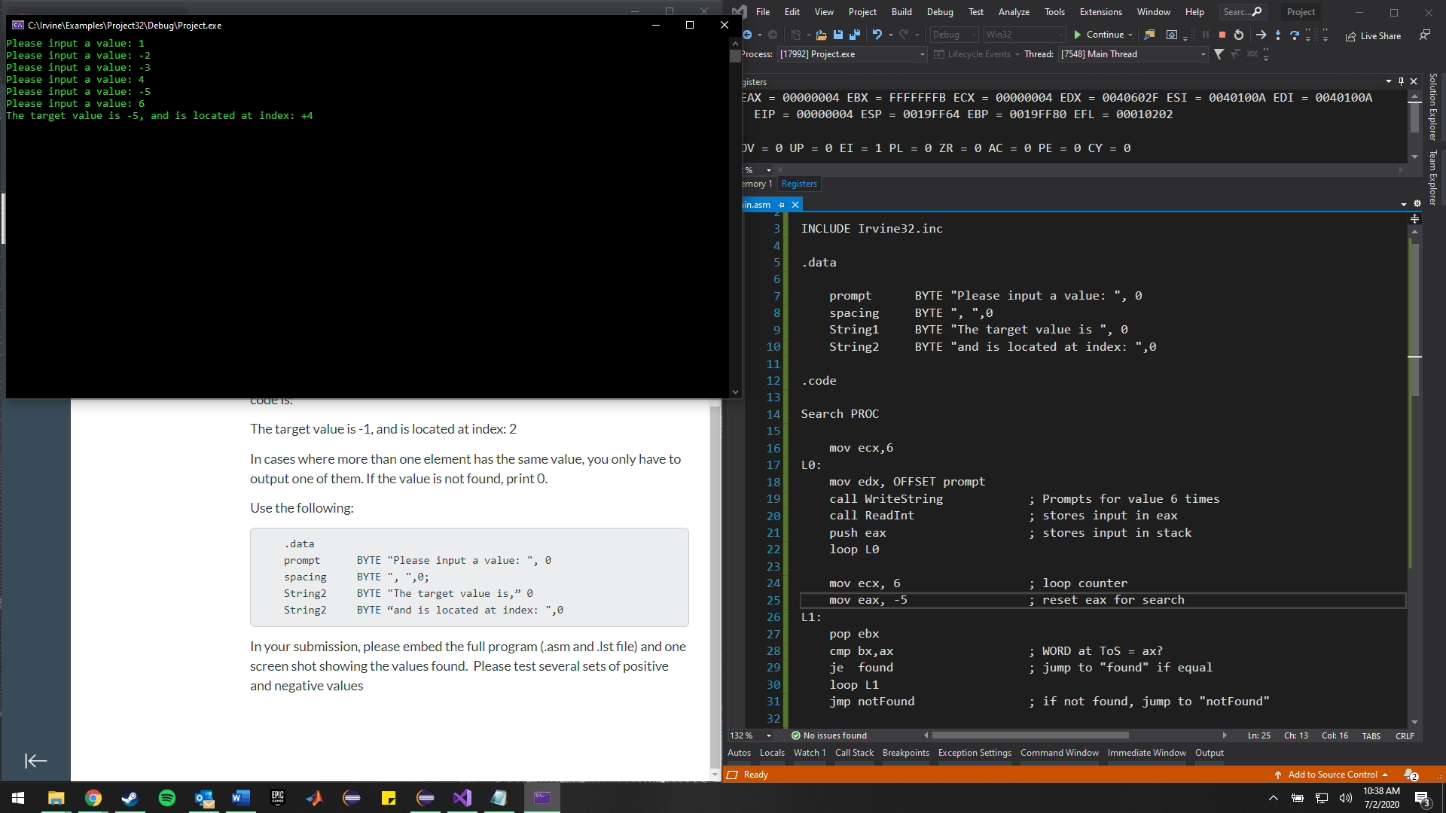

Testing a negative value with + and – inputs. Target is -5.